GBW Ambassadors: creating a Facebook account

The instructions outlined below are designed for if you do not yet have a Facebook account, or if you would like to create a new account for GBW use.

For example, you can have a personal Facebook account and a second account which is for GBW work. The two accounts are linked to two different email addresses. In Facebook, the email address that you use is basically your ‘username’ and it is also how Facebook shares news with you (e.g. if someone has requested to be your ‘friend’ on Facebook or if you have a new message). You can also look up other people on Facebook via their email address.

If you already have a Facebook account that you are happy to use for Ambassadorial purposes, you do not need to follow the steps below. If this is the case, please let me know the email address to which this account is affiliated so that I can look you up on Facebook and invite you to the GBW Ambasssador group.

1. Find a photo of yourself that you would not mind sharing with fellow Ambassadors (any appropriate shot will do – if you are birdwatching/filling a feeder etc. all the better but this is not necessary). Crop the photo if you wish (e.g. using software that comes with your camera, or in Microsoft Word or PowerPoint) and save this photo somewhere on your computer.

2.
a) Open your web browser (e.g. Internet Explorer)
b) In the address bar type www.facebook.com
c) Fill in the details in the ‘Sign Up’ section

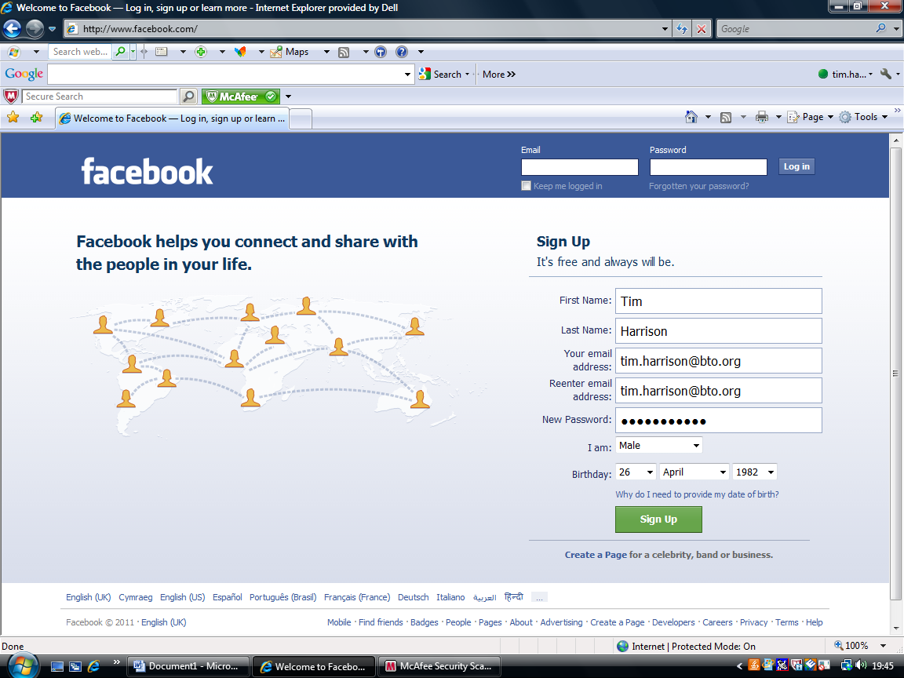
Notes:
- ‘New password’ will be the password for your Facebook account. This may or may not be the same password that you use for your email account – it does not matter.
- ‘Birthday’ is a mandatory field. Facebook asks for this so that users receive appropriate content (and, I’m sure, so that Facebook can place any adverts more effectively). For full details click: ‘Why do I need to provide my date of birth?’. Date of birth can be hidden on the Facebook page that you will create, so this can be kept private. I’ll explain how to do this in step 6.

When you’re done, click the green ‘Sign Up’

You will then be taken to a security check (to ensure that you are a real person and not a spamming computer). Be aware that the words that you transcribe here might be case sensitive. Click ‘Sign Up’.

3. You will now be forwarded to a screen that is designed to get you started in three steps. Because your use of Facebook might be for quite specific purposes (e.g. just for Ambassadorial work) I would skip these steps. You can always come back and do these things another time. You can also upload your profile picture in a min, so skip this too. So:

Step 1: click skip
Step 2: click skip
Step 3: click skip

4. Open a new window in your Internet browser and go to the inbox of the email account that you used when registering with Facebook (i.e. in 2. above). There should be two emails from Facebook waiting for you. Ignore the email that is entitled ‘Welcome to Facebook’ (this can be deleted) and open the email entitled ‘Just one more step….’ – click the green box that reads ‘Complete Sign Up’. You will then be taken back to Facebook. Enter your email address and your Facebook password. You can check the box to ‘keep logged in’ if you wish but I recommend that you do not tick this box if you are using a shared computer, particularly in a library etc.

Click ‘log in’ and you will see the message ‘account confirmed’. You are basically now up and running! All of the core information is in place and the rest is tweaking and getting started.

5. Each Facebook user has their own ‘profile page’ (see screen-grab below) which they can manage as they see fit (I’ll tell you how to get to this page in a min). The space in which material can be added to this page is known as your ‘wall’. People can post messages or photos on your wall, but you are the sole administrator of your profile page meaning that you can delete entries, add photos, change your settings etc. Your profile page can be seen by others, although you can restrict this with your privacy settings (see 6). Whenever you want to return to your profile page from anywhere within the Facebook site, go to the top right of the screen and click on your name (next to ‘find friends’). Below is an annotated profile page below to outline some of the key features.
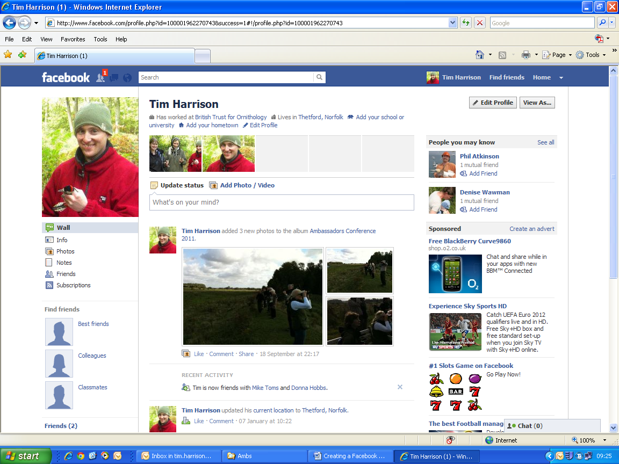
Sponsored links added by Facebook. This is how they make their money – by advertising.
As you add Friends to Facebook, it automatically suggests people who you might know and might like to be friends with. It is up to you whether you add them as friends or not.
This is your ‘status update’ – it is basically a newsfeed that you can share with your friends on Facebook. For example, I might post – ‘Enjoying hearing the Robins singing again after finishing their moult’
These three symbols tell you if you have any new notifications (e.g. if someone has commented on one of your photos, or requested to be your friend).
Where to click to return to your profile page

This is your ‘wall’ where you and others can post information (e.g. photos, as you can see here). Circled red are two options that you might use: if you like what someone has posted you can click ‘like’ (which might draw other peoples’ attention to this too); you can also comment on posts on your wall.
This is the profile picture. This is where your uploaded profile pic will appear.

Go to your Profile Page now by clicking on your name in the top right hand corner. During this process, Facebook is likely to pop up quite a few dialogue boxes to try to help get you started – just close these boxes for now, you can always revisit these later on.

When you get onto your profile page for the first time you will have the option of adding a range of information. Fill in the information that you wish to provide (if any).

It is now time to add your profile picture (i.e. the photo that you have saved on your computer). On the top left of your profile page, click ‘upload photo’. Click ‘choose file’, click ‘find’, click on the photo that you want to use and click ‘open’. The message will come on screen reading ‘uploading photo’. The photo will then appear on your screen and has been saved as your profile picture.

6. Editing your privacy settings/other settings

Go back to your Profile Page by clicking on your name in the top right hand corner. Click ‘Edit Profile’ near the top right of the page. Below is illustrated the settings for an account. You can add a current location and hometown if you wish. For each bit of information here, you can decide how accessible you want it to be by clicking on the corresponding symbol (highlighted by drawing on a light blue rectangle around them): ‘public’ means anyone on Facebook can see these details; ‘friends’ means that only people that you approve as your friends on Facebook can see them; ‘only me’ means these details are private; ‘custom’ is where you specify settings yourself. As a general rule if helpful, I tend to put my settings on ‘friends’ so that Facebook friends can see them but no-one else.

Click ‘save changes’ – you will see a green tick and message to let you know that your details have been saved.

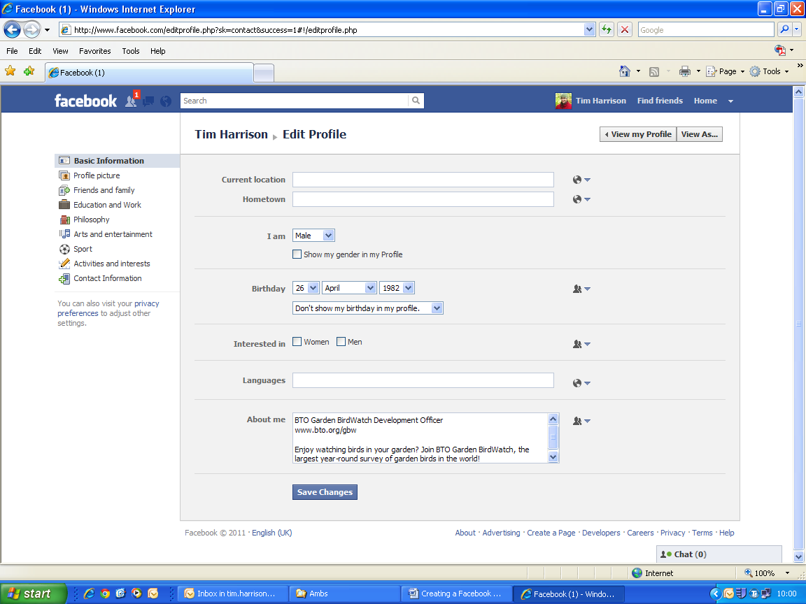

Now go through the different layers of information highlighted with the orange box above. For each of these layers, remember to hit save if you make changes.

Click on ‘profile picture’ and you should see the photo that you have just uploaded. Click on ‘friends and family’ – here you can include ‘relationship status’, etc. ‘Education and Work’ you can include what you have done in the past. ‘Philosophy’, ‘Arts and Entertainment’, ‘Sport’ and ‘Activities and Interests’ is pretty pointless. ‘Contact Information’ is where you can advertise your email address and though I’d recommend you only make this available to friends.

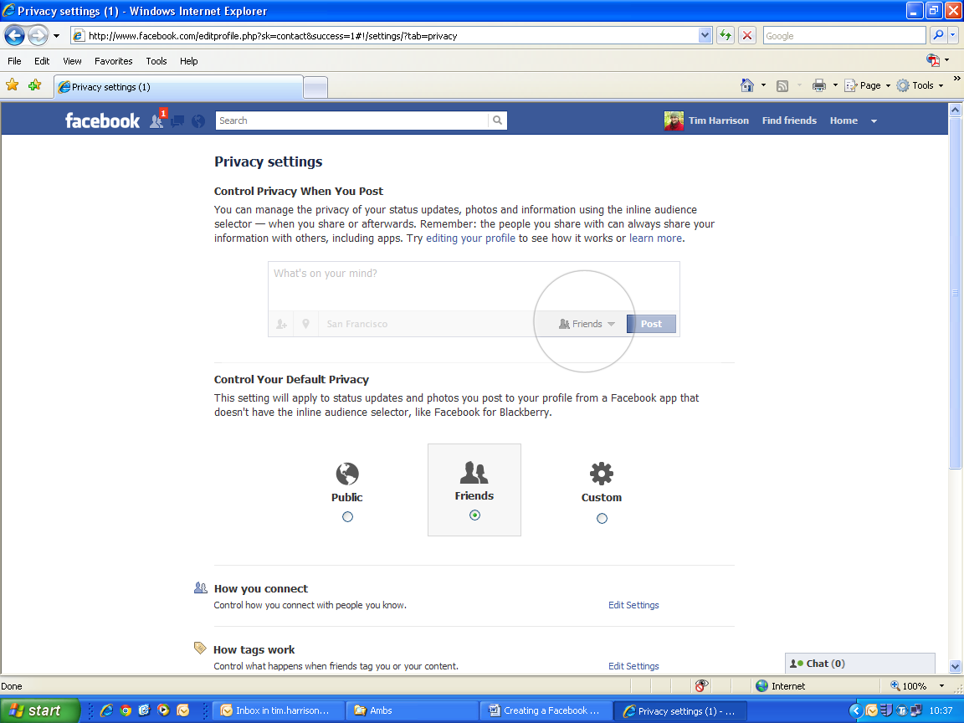
Finally, click on ‘privacy preferences’ (in the green box on the screen grab above). The screen below will then appear. Please read the annotations on the screen grab below and act accordingly.
When you post information – e.g. a ‘status update’ on your profile page (see step 6) – you can modify who you want to see this information (see area circled in light grey here). If you do not adjust this (you do not have to), Facebook will use the default settings that you stipulate below.
Set your default privacy setting here. ‘Public’ means that anyone on Facebook can see your profile page and other details that you have given; ‘friends’ restricts this to just Facebook friends; ‘custom’ is self-explanatory. I have opted for ‘friends’ as this means I am only sharing info with people who I know.

Now click ‘edit settings’ to the right of ‘how you connect’, and the following pop-up box will appear. If you keep the first three options as ‘everyone’ it makes it easier for other Facebook users to look you up. However, I recommend you keep the bottom two options as ‘friends’ so that only friends can see what is on your profile page and can post on your wall. Click ‘done’.

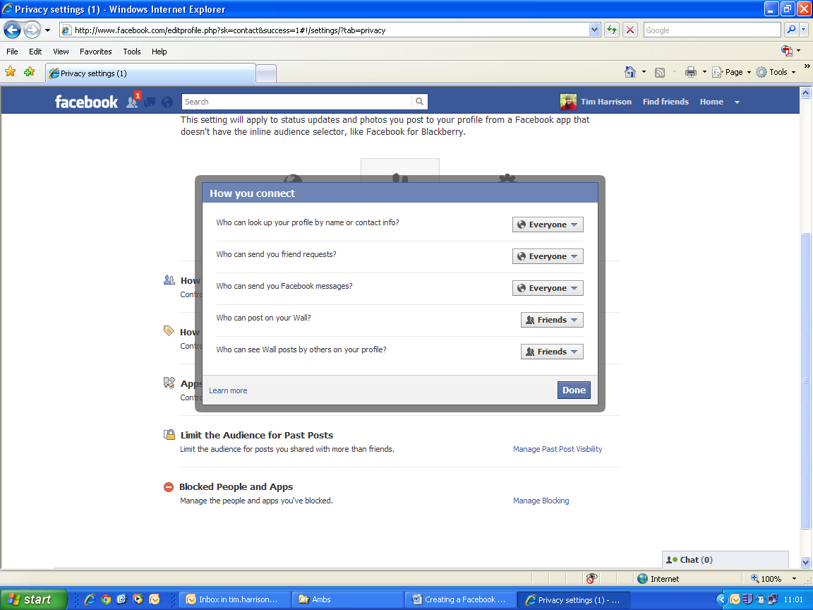

Click ‘edit settings’ to the right of ‘how tags work’. Explore the options to find out more, but I think the settings below are good – enabling fluid interaction between Facebook friends (which is the whole point of the site) but not opening up the profile page/details to non-Facebook friends.

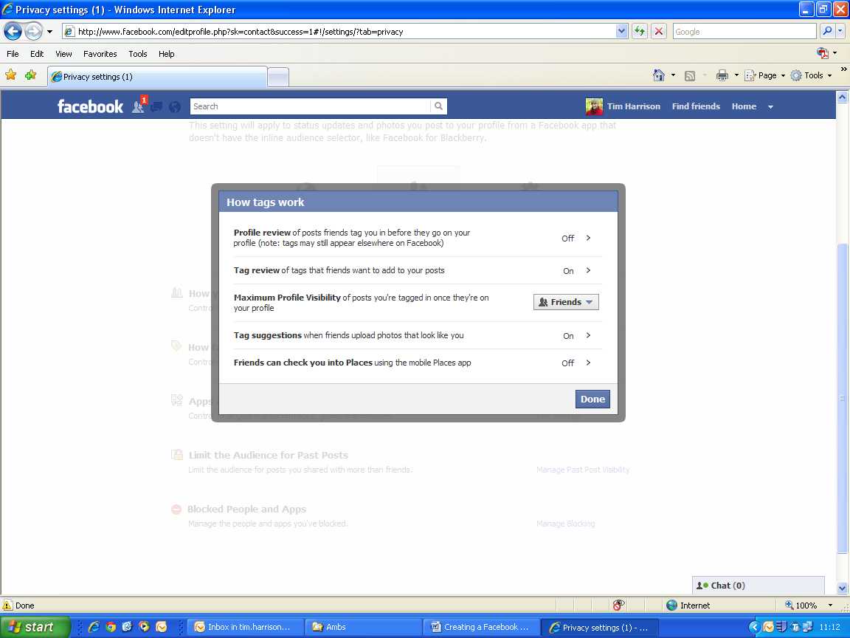

Click ‘Edit settings’ to the right of ‘Apps and websites’. ‘Apps you use’ should not be applicable as you will not have any loaded. Click on ‘edit settings’ to the right of ‘Information accessible through your friends’. I have unchecked all of the boxes here as this is information that might otherwise be shared inadvertently through fellow Facebook friends (i.e. I have no control over this) – click ‘save changes’. Click ‘edit settings’ to the right of ‘instant personalisation’ – again this is up to you but I have unchecked the box that reads ‘Enable instant personalisation on partner websites.’ Click ‘edit settings’ to the right of ‘public search’ – I have unchecked the box ‘Enable public search’ so that this is not possible.

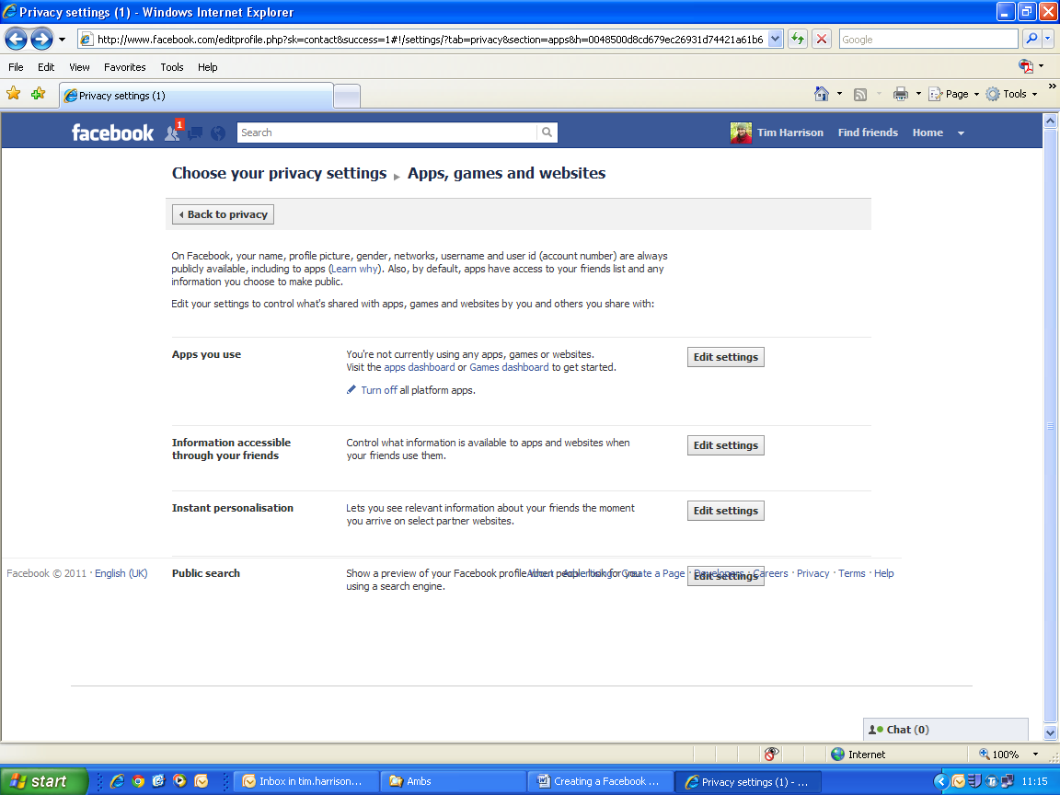

Click ‘Back to privacy’ in the top left corner.

Observe ‘Limit the Audience for Past Posts’ – this should not be applicable at this stage, so ignore.

Observe ‘Blocked People and Apps’ – this might be something that you use to block people or apps further down the line. But right now you don’t need to do anything.

Click on your name in the top right hand corner to return to your profile page. Click on ‘Home’ to the right of where you have just clicked on your name.

8. ‘Home’ and the GBW Ambassadors Group

The page that you are on now is the one that you will arrive on every time that you log into Facebook. This is your Facebook ‘Home’ (see example below).

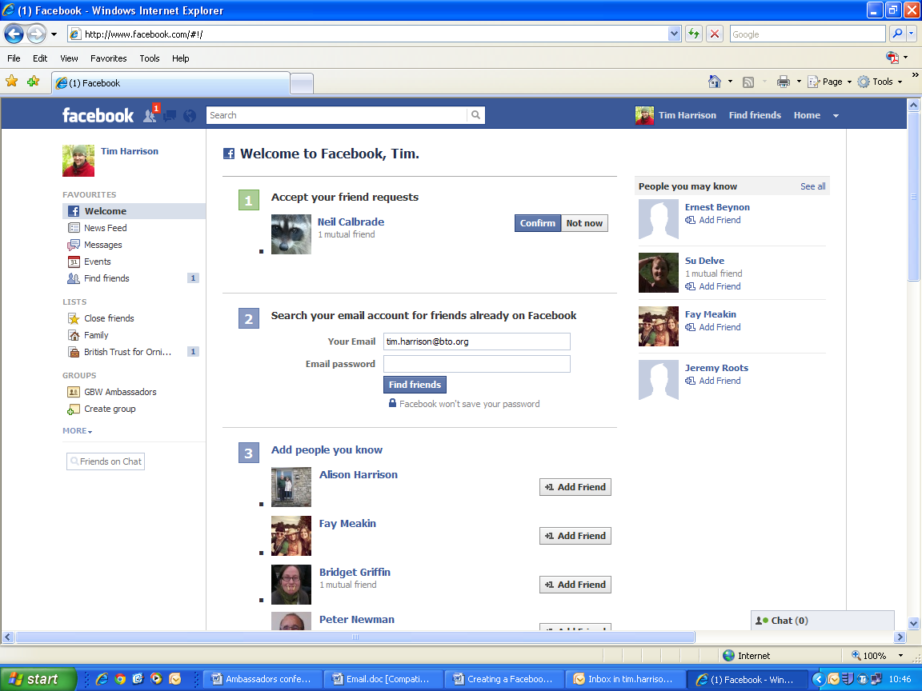

As you get more Facebook friends added, this page forms a newsfeed for what they are up to. It can be a really nice way of staying in touch. Depending on your privacy settings (i.e. see 6 above) material from your profile page, such as status updates, may be shared with your friends on this Home page. As you start a new Facebook account, however, there will not be much happening on this page (e.g. see screen grab above from a new account). Here, instead of news from Facebook friends, Facebook has mainly populated the space with material to try to get me up and running. Ignore this material for now.

Look on the left hand side of the page. Can you see ‘GROUPS’ and below that ‘GBW Ambassadors’ (circled red above)? If not, this means I have been away from my computer and I have not been able to approve the friend request that you sent to me in step 4 above, and I have not been able to invite you to join the GBW Ambassadors group. If this is the case, please go to step 7 below and come back later to join the GBW Ambassadors group.

If you can see ‘GBW Ambassadors’ (under ‘GROUPS’), please click on this now.

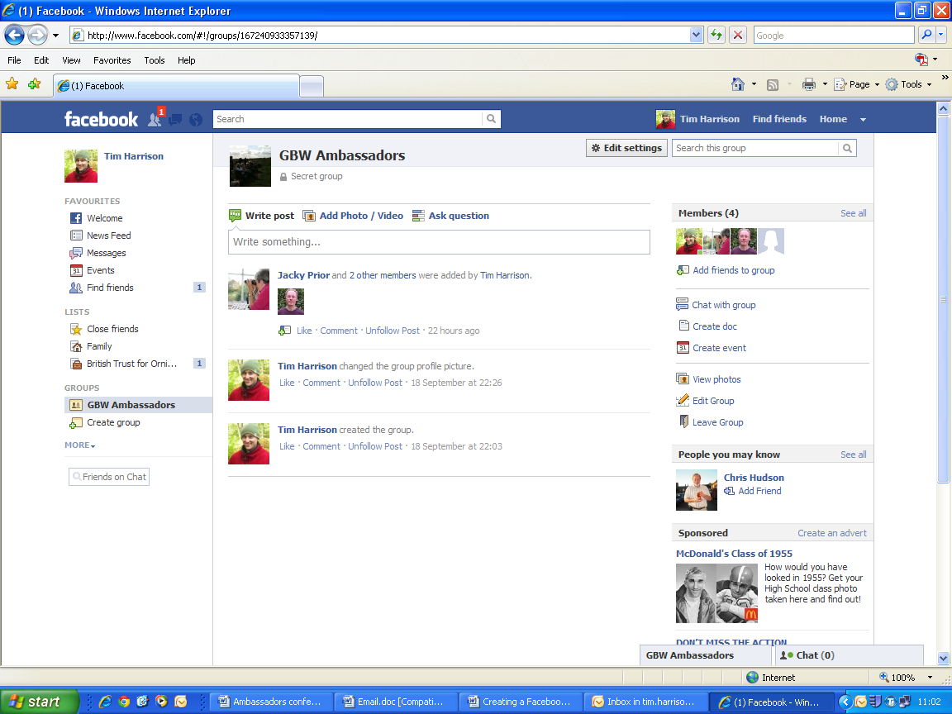
Name of group and confirmation that this group is ‘secret’ (i.e. only group members can view this group and only I can invite people to join).
As with the ‘wall’ area for your profile page, this is the ‘wall’ area for the GBW Ambassadors group. Here, you can post photographs of events, mention any upcoming events that you have, provide feedback on events that have just occurred, comment on posts by other Ambassadors, provide advice etc. This should be a really dynamic area and will really get us all talking. Whenever someone posts on the wall, all group members will get an email to their email account to tip them off.
This bit tells you who else belongs to the GBW Ambassadors group. Clicking on any of these photos takes you to that person’s profile page (depending on their privacy settings)

7. Logging out
Before logging out, please take some time just to explore other buttons on Facebook to see how it all works – this really is the best way of learning.

Logging out is an important thing to do, particularly on a shared computer. When you are ready to log out, click the downwards-pointing arrow to the right of ‘Home’ in the top right corner of the screen, and then click on ‘Log out’. To log in again visit www.facebook.com again.

